Resources taken from: http://www.ala.org/emiert/cskbookawards/recipients
African American Children’s Books (Coretta Scott King Award)
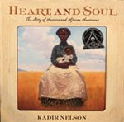  Kadir Nelson, author and illustrator of “Heart and Soul: The Story of America and African Americans” (Balzer + Bray, an imprint of HarperCollins Publishers). “Heart and Soul: The Story of America and African Americans” is an extensive volume focusing on American history as it intertwines with the lives of African Americans. The story is told from the viewpoint of an elderly woman who shares her life story while highlighting pivotal historical events including abolition, the Great Migration, World War II, and the Civil Rights movement. | 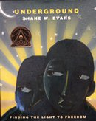  Shane W. Evans, illustrator of “Underground: Finding the Light to Freedom” (A Neal Porter Book, published by Roaring Brook Press, a division of Holtzbrinck Publishing Holdings Limited Partnership). Effective interplay of dark and light—dark blues and greens that represent fear and oppression; bright golds that signal the joy of freedom—characterizes this portrayal of a band of slaves’ nighttime escape. They run, rest, get help from others, and finally celebrate their hard-won liberation. | 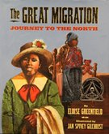  Eloise Greenfield, “The Great Migration: Journey to the North,” illustrated by Jan Spivey Gilchrist and published by Amistad, an imprint of HarperCollins Publishers. | 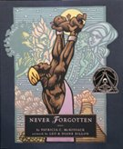  Patricia C. McKissack, “Never Forgotten,” illustrated by Leo and Diane Dillon and published by Schwartz & Wade Books, an imprint of Random House Children’s Books, a division of Random House, Inc.
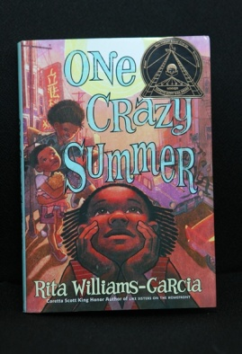  Rita Williams-Garcia, author of One Crazy Summer (Amistad, an imprint of HarperCollins Publishers). Eleven-year-old Delphine and her two younger sisters travel to Oakland, Calif. in 1968 to face the emotional challenge of reaching out to a distant mother and learn about a different side of the Civil Rights Movement. Themes of friendship, family and identity intertwine with broader social issues in this compelling historical novel. | 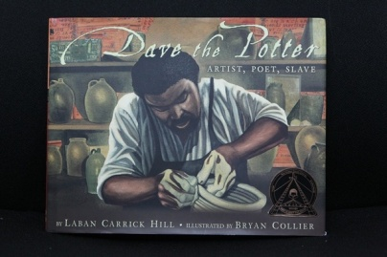  Bryan Collier, illustrator of Dave the Potter: Artist, Poet, Slave, written by Laban Carrick Hill (Little, Brown and Company, a division of Hachette Book Group, Inc.). Dave, a slave in 19th century South Carolina, demonstrated extraordinary talent and skill to achieve creative success. At a time when it was illegal for slaves to read and write, the eloquent poetry on Dave’s remarkable pots provided inspiration and hope to those who had none. |   Walter Dean Myers, author of Lockdown (Amistad, an imprint of HarperCollins Publishers). | 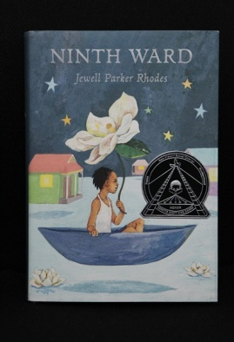  Jewell Parker Rhodes, author of Ninth Ward (Little, Brown and Company, a division of Hachette Book Group, Inc.).
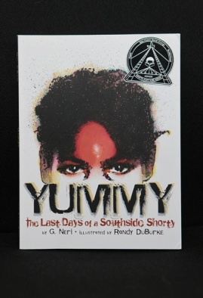  G. Neri, author of Yummy: The Last Days of a Southside Shorty, illustrated by Randy DuBurke (Lee & Low Books, Inc.). | 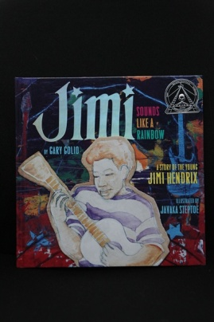  Javaka Steptoe, author of Jimi: Sounds Like a Rainbow: A Story of the Young Jimi Hendrix, written by Gary Golio (Clarion Books, an imprint of Houghton Mifflin Harcourt Publishing Company). | 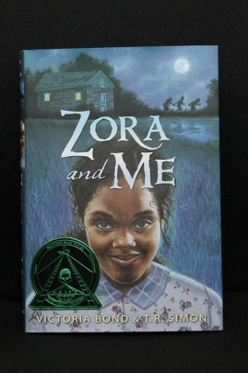  Victoria Bond and T. R. Simon, authors of Zora and Me (Candlewick Press). | 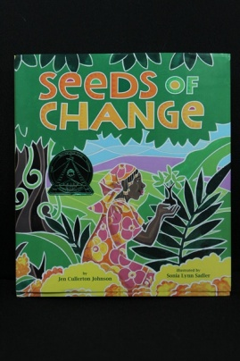  Sonia Lynn Sadler, illustrator of Seeds of Change, written by Jen Cullerton Johnson (Lee & Low Books, Inc.).
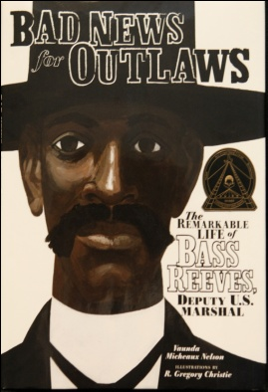  Vaunda Micheaux Nelson, author of Bad News for Outlaws: The Remarkable Life of Bass Reeves, Deputy U.S. Marshal, illustrated by R. Gregory Christie (Carolrhoda Books, a division of Lerner Publishing Group, Inc.). | 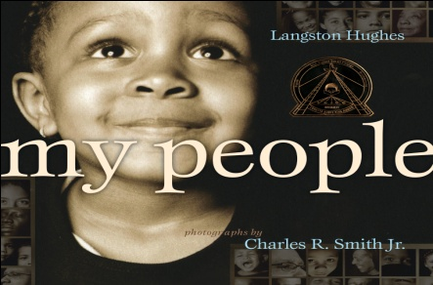  Charles R. Smith, Jr., illustrator of My People; text by Langston Hughes (ginee seo books, Atheneum Books for Young Readers). | 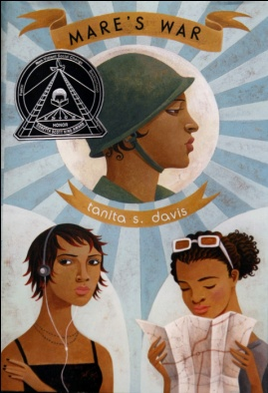  Tanita S. Davis, author of Mare’s War (Alfred A. Knopf, an imprint of Random House Children’s Books, a division of Random House, Inc.). | 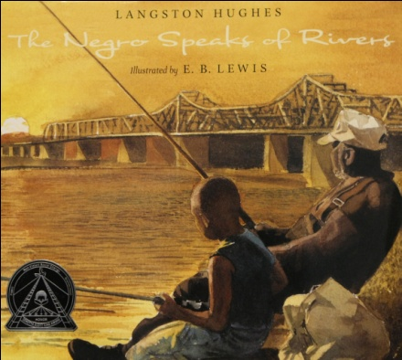  E.B. Lewis, illustrator of The Negro Speaks of Rivers; text by Langston Hughes (Disney - Jump at the Sun Books, an imprint of Disney Book Group).
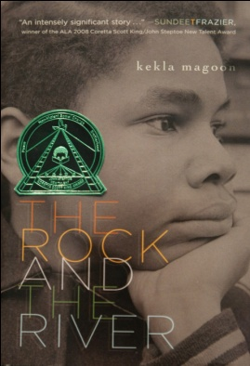  Kekla Magoon, author of The Rock and the River (Aladdin, an imprint of Simon & Schuster Children’s Publishing Division). | 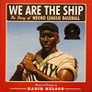  Kadir Nelson, author and illustrator of We Are the Ship: The Story of Negro League Baseball (Disney-Jump at the Sun, an imprint of Disney Book Group). | 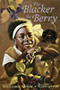  Floyd Cooper, illustrator of The Blacker the Berry, written by Joyce Carol Thomas (Joanna Cotler Books, an imprint of HarperCollins Publishers). | 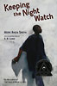  Hope Anita Smith, author of Keeping the Night Watch (Henry Holt and Company).
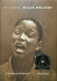  Carole Boston Weatherford, author of Becoming Billie Holiday (Wordsong, an imprint of Boyds Mills Press, Inc). | 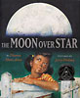  Jerry Pinkney, illustrator of The Moon Over Star, written by Diana Hutts Aston (Dial Books for Young Readers, a division of Penguin Young Readers Group). | 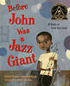  Sean Qualls, illustrator of Before John Was a Jazz Giant, by Carole Boston Weatherford (Henry Holt and Company).

Resources taken from: http://www.ala.org/alsc/awardsgrants/bookmedia/belpremedal
Latino American (Pura Belpre Award)
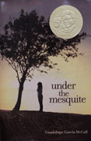  Under the Mesquite, by Guadalupe Garcia McCall, published by Lee and Low Books Inc.  In “Under the Mesquite,” Garcia McCall, writing in emotionally riveting free verse, gracefully manages to convey the experience of growing up in a bicultural community in Texas with geographical accuracy and a radiating authentic voice for its main protagonist fourteen-year-old Lupita, the oldest of eight children who is dealing with her mother’s terminal illness.  “Garcia McCall deftly communicates not only the experience of a youth losing her mother to cancer but that of a child surrounded by siblings embracing and discarding their Mexican roots in various degrees,” said Naidoo. | 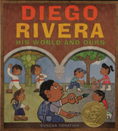  Diego Rivera: His World and Ours, written and illustrated by Duncan Tonatiuh, published by Abrams Books for Young Readers, an imprint of ABRAMS  Diego Rivera: His World and Ours highlights the accomplishments of Mexican painter, activist, and muralist Diego Rivera. Tonatiuh’s stylized illustrations include elements of Mayan artwork and represent his interpretation of Diego’s original artwork, answering the question: what would Diego paint today? Through eye-catching digital collage, Tonatiuh juxtaposes contemporary Mexican life with the past.  “Tonatiuh’s visually appealing, layered artwork rendered in a mural style pays homage to Diego’s paintings while balancing traditional images with modern twists,” said Pura Belpré Award Committee Chair Jamie Campbell Naidoo. | 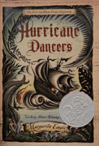  Hurricane Dancers: The First Caribbean Pirate Shipwreck by Margarita Engle, published by Henry Holt and Company, LLC.  Engle’s beautifully written poetic narrative cuts to the heart of an untold story in Latin American history and describes the enslavement of the native peoples of the Caribbean by the Spanish along with the mixing of Spanish and native blood that now forms the vast majority of Latin America. Told from several points of view, the story captures the rhythm and sounds from a time long ago and encourages readers to explore Latino culture on their own.
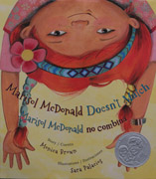  Marisol McDonald Doesn’t Match /Marisol McDonald no combina illustrated by Sara Palacios, written by Monica, and published by Children’s Book Press, an imprint of Lee and Low Books Inc.  Bright and vivacious Marisol, a young Peruvian-Scottish-American girl, loves peanut butter and jelly burritos and speaks both English and Spanish. Unfortunately, her teacher and classmates do not appreciate Marisol’s mashing of cultures. Using mixed media techniques, Palacios’ illustrations exude child appeal and biculturalism, allowing astute visual readers to identify the blending of cultures. | 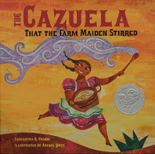  The Cazuela that the Farm Maiden Stirred illustrated by Rafael López, written by Samantha R. Vamos, and published by Charlesbridge.  Nothing is better than a delicious bowl of arroz con leche unless, of course, a host of farm animals have a hand in the preparation! Lopez’s blazing illustrations for the rhythmic, rollicking cumulative tale, “The Cazuela that the Farm Maiden Stirred” radiate a cheerful exuberance and are peppered with Latino cultural details that extend Vamos’ perky narrative. | 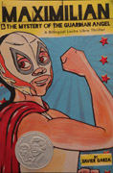  Maximilian and the Mystery of the Guardian Angel: A Bilingual Lucha Libre Thriller written by Xavier Garza, published by Cinco Puntos Press.  Xavier Garza successfully captures the excitement that Max, an eleven-year-old Mexican-American boy, displays when he discovers that his favorite Lucha Libre wrestler is coming to town and might have a strange connection with his own family! This action packed bilingual mystery novel uses playful language that reinforces elements of Mexican-American culture and overflows with almost unbridled excitement for Lucha wrestling.

Resource taken from: http://www.pragmaticmom.com/2010/09/top-10-best-latino-american-children%E2%80%99s-books-ages-2-16/
Top 10: Best Latino American children’s Books (ages 2-16)

Recommended Picture Books with Latino Themes
Resource Taken from: http://ccb.lis.illinois.edu/Projects/Additions%20on%209-20-07/CCB/CCB/mhommel2/picturebooks.html
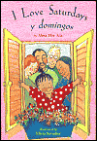  **Ada, Alma Flor. I Love Saturdays and Domingos. Illus. by Elivia Savadier, Atheneum, 2002. Gr. Pre-3  On Saturdays, the young narrator visits her Grandma and Grandpa. On domingos, or Sundays, she visits Abuelito y Abuelita. The story shows the differences between the sets of grandparents—but highlights the continuity of the love that is shared. A final spread shows her whole family coming together—including grandparents, parents, and cousins, to celebrate the narrator’s birthday. The text does a nice job of portraying the two cultures—Spanish vocabulary is especially well-integrated--and this will appeal to children who are from bicultural backgrounds, or who love spending time with their grandparents. Bouncy, energetic watercolor spot illustrations in bright colors bring the text to life. | 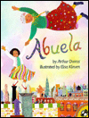  Dorros, Arthur. Abuela. Illus. by Elisa Kleven. Dutton, 1991. Gr. K-3  Rosalba’s abuela speaks mainly Spanish, likes adventures, and takes her granddaughter to the park. Rosalba daydreams that they fly over the city of New York to the land where her abuela was born, over the statue of liberty and back. Spanish words are carefully included and skillfully explained in context, without Abuela ever speaking a word of English. Lively collages of watercolor, pastels, and cut paper provide a visual feast of details and life that make the adventure and city come alive. | 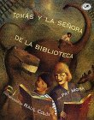  Mora, Pat. Tomás and the Library Lady. Illus. by Raul Colón. Random House, 1997. Gr. 3-5  Encouraged by his storytelling grandfather, Tomás, son of migrant workers, escapes to the library on hot days as his parents work in the fields. There, a librarian takes him in, offering books, reading with Tomás, and even letting him take books home in her name. Eventually, his family must move on to other fields, but he carries the love of reading with him. Scratchboard art is done in warm, earth-tone colors, and Tomás’ reading adventures unfold across the pages. Based on a true story about Tomás Rivera, who eventually became the chancellor of the University of California at Riverside and inspired the Tomás Rivera Mexican American Children’s Book Award, founded in his honor.
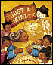  **Morales, Yuyi. Just a Minute: A Trickster Tale and Counting Book; written and illus. by Yuyi Morales. Chronicle, 2003. Gr. 1-4  The motif of a person tricking death is well-used, but Yuyi Morales (also the illustrator of Kathleen Krull’s Harvesting Hope) breathes new vitality into the tale in Just a Minute: A Trickster Tale and Counting Book. Señor Calavera comes for Grandma Beetle, but she is not yet ready to go… she counts her way through the bookweith one/uno swept house, two/dos steaming pots of tea, three/tres pounds of corn, and on to ten. Señor Calavera realizes that Grandma Beetle is stalling him, but by that time he is having so much fun at her birthday party, that he decides to put off her time. The art is a vivid palette of fuschia, teal, gold, and royal blue, and each spread shows movement and personality. Would be a great readaloud.  Winner of Pura Belpré Award 2004, Américas Award 2003 | 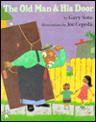  Soto, Gary. The Old Man and the Door. Illus. by Joe Cepeda. Putnam, 1996. Gr. 1-4  "In Mexico, there’s a little song that goes like this: 'La puerta. El puerco. There’s no difference to el viejo.'" And when the Viejo, or old man, in this story misunderstands his wife’s words, he carries a door (puerta) to the barbecue instead of the pig (puerco). What ensues is a humorous series of events in which the door comes in very handy, from rescuing a drowning child to helping a young man move a piano. Cepeda’s vibrant, chalky illustrations provide humor and enhance the story. A humorous and read-aloudable story set in Mexico. | Soto, Gary. Too Many Tamales. Illus. by Ed Martinez. Putnam, 1993. Gr. K-4  Part of the Christmas traditions at Maria’s house includes making lots and lots of tamales. Maria borrows her mother’s diamond ring as she kneads the masa, or dough and it isn’t until later that night she realizes her mother’s ring is gone, and must be inside one of the tamales! This is a humorous, gentle family story, and one of the few depictions of middle-class Mexican American life. A great Christmas story to share. Lifelike expressions enliven the detailed sepia, gold, and ochre oil illustrations.
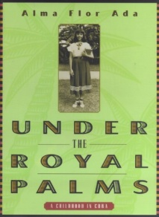  Ada, Alma Flor. Under the Royal Palms: A Childhood in Cuba. Atheneum, 1998. Gr. 4-6  Ada describes her childhood in Cuba in this companion volume to her first memoir, The Flame Trees. Her childhood is portrayed through a series of episodes, and the rich detail of her family and her surroundings come through. | 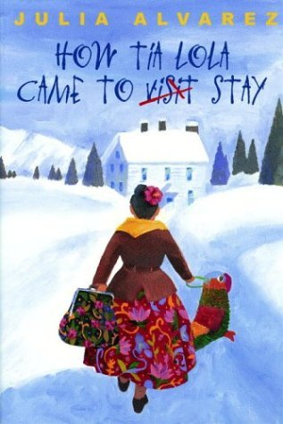  Alvarez, Julia. How Tía Lola Came to Visit Stay. Knopf, 2001. Gr. 3-6  Miguel has enough to adjust to, with moving from New York to Vermont and leaving his father behind. Then comes Tía Lola from the Dominican Republic to visit and help. She’s embarrassing and overbearing and Miguel can’t wait for her to leave, but his perspective starts to change as he sees the positive she brings to him, his family, and the community. Alvarez does a good job of creating real and sympathetic characters in this is a funny, heartfelt novel, and kids who are going through transitions of their own will find comfort here. Spanish is used throughout the book, but is defined in-text. | 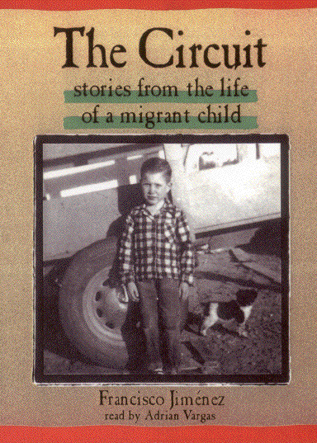  **Jiménez, Francisco. The Circuit: Stories from the Life of a Migrant Child. University of New Mexico, 1997. Gr. 5-9  As a young child in Mexico, Jiménez was told by his parents that they were going north to the U.S. to seek work. There begins the autobiographical tale of The Circuit, where Jiménez tells of his childhood as a migrant worker, suffering hardships and mistreatment, traveling from farm to farm seeking work, his family making too little to set up a permanent home. Jiménez’s circumstances were made more difficult because he dreamed of going to school, but his family’s constant upheaval made this next to impossible. This is a moving story that shouldn’t be missed. Readers will be eager for his sequel, Breaking Through, when they finish this installment.
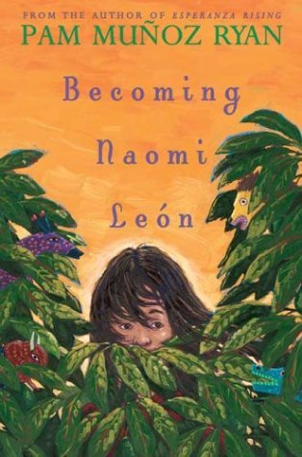  Ryan, Pam Muñoz. Becoming Naomi León. Scholastic, 2004. Gr. 4-7  Everything is going just fine for Naomi, her Gram, and her younger brother Owen when her mother shows up. When things turn sour and Naomi’s mom tries to separate her from Gram, the three escape to Mexico in search of Naomi’s father. There is a lot of warmth in this story of a poor family that’s rich with love, and Ryan manages to weave in Mexican culture. However, the plot is a bit contrived at times and the Naomi's mother a bit one-dimensional, and this book doesn’t quite live up to Esperanza Rising. | **Ryan, Pam Muñoz. Esperanza Rising. Scholastic, 2000. Gr. 5-8  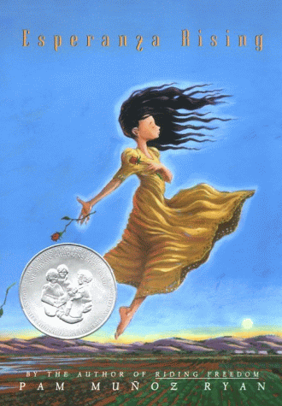  Esperanza is the content daughter of a wealthy ranchero in Mexico until an unfortunate turn of events sees her father dead, her house burned, and she and her mother penniless. They are forced to flee to the U.S., where with the help of their former servants, they try to make their way as campesinos, or farm workers. This is on one hand the story of one girl and her journey to maturity, on the other hand a moving tale of migrant workers and their struggles in the U.S. Questions here are not easily answered, and Ryan weaves a beautiful, complex story with tenderness for each character she portrays.
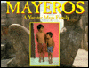  Ancona, George. Mayeros: A Yucatec Maya Family; illus. with photographs. Latrop, 1997. Gr. 2-5  Mayas have been living on the Yucatán for four thousand years, and in this book Ancona visits the village where his chichí (Mayan word for grandmother) grew up. Vivid photographs detail the everyday lives of the people and Ancona’s narration fills in the gaps and expands with history, culture, and background information. This is an accessible book that gives a good look inside another culture. A forward and author’s note round out the history and lend authority. A truly engaging book for anyone who wants a glimpse at an ancient culture and how it exists today. | 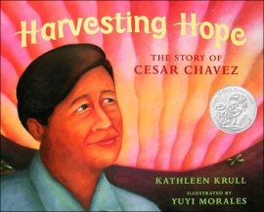  Kathleen Krull. Harvesting Hope: The Story of Cesar Chavez. Illus. by Yuyi Morales. Harcourt 2003. Gr. 2-5  The story of Cesar Chavez, hero of Mexican-American farm workers and founder of the National Farm Workers Association, is told in a kid-accessible way. Krull begins with Chavez’s childhood, works her way through his early adulthood, and tells of his many accomplishments as an activist. Though the story is a bit simplified, she manages to convey the incredible importance Chavez had for many of the poorest Americans, and to give a sense of how Chavez may have come to be in this position. Yuyi Morales’s art reflects the sun-burnt feel of the fields and the passion of the people with her palette of crimson, fuchsia, gold, and aqua, and the movement and immediacy of each picture. | 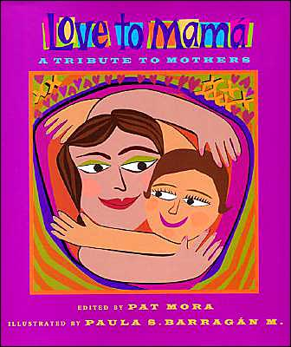  Mora, Pat, ed. Love to Mamá: A Tribute to Mothers; illus. by Paula S. Barragán M. Lee & Low, 2001. Gr. 3-5  This collection of poems by various Latino authors centers around mothers. From a mamá cubana cooking arroz con pollo to visits from grandmothers to a goodbye on the first day of school, the poems are in turns humorous, touching, and exciting. The art, done in a collage of cut paper, gouache, and pencil, is vivid and alive. Though some of the poems are a bit weaker than others, it’s an overall touching and solid collection.

Resource Taken from: http://www.childrensliteraturenetwork.org/resource/readlist/favnatv.php
Children’s Literature Network
Best Native American Books for Children and Young Adults
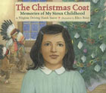  The Christmas Coat: Memories of My Sioux Childhood  Virginia Driving Hawk Sneve  Holiday House, 2011  Ages 5 to 8  Virginia and her brother are never allowed to pick first from the donation boxes at church because their father is the priest, and she is heartbroken when another girl gets the beautiful coat that she covets. Based on the author's memories of life on the Rosebud Reservation in South Dakota. | 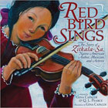  Mohala Mai 'o Hau: How Hau Became Hau`ula  Robert Lono ‘Ikuwā  illustrated by Matthew Kāwika Ortiz  Kamehameha Publishing, 2010  Ages 5 to 10  Hau, a young girl from Ko’olauloa, is overshadowed by her beautiful and talented older sisters named Niu, Puhala, and Lehua. But with the help of her kupuna, Hau begins to blossom as she discovers her unique talents and contributions. | 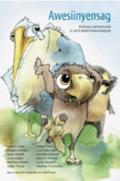  Awesiinyensag  authors and editors Nancy Jones, Eugene Stillday, Rose Tainter, Anna Gibbs, Marlene Stately, Anton Treuer, Keller Paap, Lisa LaRonge, Michael Sullivan, John Nichols, Lucia Bonacci, and Heather Fairbanks  illustrated by Wesley Ballinger  Wiigwaas Press, 2011  All ages  Awesiinyensag presents original stories, written in Anishinaabemowin, that delight readers and language learners with the antics of animals who playfully deal with situations familiar to children in all cultures. Suitable for all ages, this book can be read aloud, assigned to classes, shared at language tables, gifted to elders, and enjoyed by those curious about the language and all who love Anishinaabemowin.
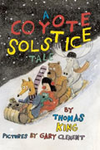  Coyote Solstice Tale  Thomas King  Groundwood Books, 2009  All ages  Wily trickster Coyote is having his friends over for a little solstice get-together in the woods when a little girl comes by unexpectedly. She leads the friends through the snowy woods to the mall—a place they had never seen before. The trickster goes crazy with glee as he shops with abandon, only to discover that filling a shopping cart with goodies is not quite the same thing as actually paying for them. | 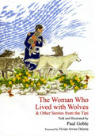  Woman Who Lived with Wolves,  and Other Stories from the Tipi  Paul Goble  World Wisdom, 2010  All ages  Twenty-six traditional stories from the traditions of the Lakota, Pawnee, Mandan, Blackfoot, Cheyenne, Ojibwa, Osage, Kiowa, and other Native American tribes. | 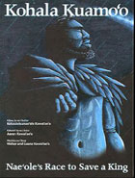  Kohala Kuamo'o: Nae'ole's Race to Save a King  Kekauleleanae'ole Kawai'ae'a  Illustrated by Aaron Kawai'ae'a  Kamehameha Publishing, 2011  All ages When a prophecy proclaims that the unborn Kamehameha would grow to overshadow the ruling chiefs, his life from birth is in danger. Nae‘ole, the trusted chiefly attendant of Kamehameha’s mother, races across Kohala to save the infant Kamehameha. The first printing of Kohala Kuamo‘o: Nae‘ole’s Race to Save a King commemorates the 200-year anniversary of Kamehameha’s unification of the Hawaiian Islands under one rule in 1810.
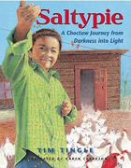  Saltypie : a Choctaw Journey  from Darkness into Light  Tim Tingle  Cinco Puntos Press, 2010  Ages 8 to 12  Choctaw author Tim Tingle tells the story of his famly's move from Oklahome Choctaw country to Pasadena, Texas. Spanning fifty years, the book describes the problems encounted by his Choctaw grandmother from her orphan days at an Indian boarding school to hardships she met at her new home on the Texas Gult Coast. It is the story of one family's efforts to honor the past while struggling to gain a foothold in modern America. | 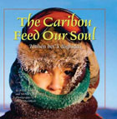  Caribou Feed Our Soul: 'étthén bet'á dághídda  Pete Enzoe  Fifth House, 2010  Ages 8 to 12  Pete Enzoe is Chipewyan Dene from Lutsel K’e, Northwest Territories, on the East Arm of Great Slave Lake. He is a hunter, fisher, and trapper. He sees his role in life as protector of the caribou and spends much of his time “reading” the land as he travels his peoples’ traditional areas. Pete also helps scientists to monitor the herd’s health and migration.  In The Caribou Feed Our Soul, the sixth book in The Land is Our Storybook series, Pete takes readers on a respectful caribou harvest. Along the way, he shares creation stories about how his people are descendants of the caribou. He also describes the spiritual areas his community is trying to protect, including Thaidene Nene, which means “land of our ancestors.” Pete’s stories help the reader to understand the rich history of the Chipewyan Dene and their relationship with the caribou today. | 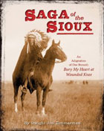  Saga of the Sioux : an adaptation from  Dee Brown's Bury My Heart at Wounded Knee  Dwight Jon Zimmerman  Henry Holt and Company, 2011  Ages 8 to 12  A lavishly illustrated adaptation for children of Brown's meticulously documented account of the systematic destruction of the American Indian during the second half of the nineteenth century.
  Free Throw  Jacqueline Guest  James Lorimer and Co, 2011  Ages 10 and up  Matthew Eagletail is the star player for the Warriors, his basketball team on the Tsuu TÃina First Nation near Calgary. When his mother remarries, everything in Matthew's life is suddenly different and new: a new school, a new father, five pesky new sisters, a new dog named Precious. Worst of all, he has to quit the Warriors. |   Triple Threat  Jacqueline Guest  James Lorimer and Co, 2011  Ages 10 and up  Matthew Eagletail's good friend, John Salton, has come to visit. Together, the boys form the Bobcats to compete in the Rocky Mountain basketball tournament | 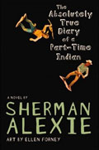  Absolutely True Diary of a Part-Time Indian  Sherman Alexie  Little, Brown, 2007  Ages 14 and up  Budding cartoonist Junior leaves his troubled school on the Spokane Indian Reservation to attend an all-white farm town school where the only other Indian is the school mascot.
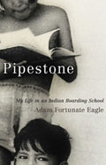

Pipestone: My Life in an Indian Boarding School
Adam Fortunate Eagle
University of Oklahoma Press, 2010
Ages 14 and up
Fortunate Eagle, a one-time leader of the 1969-1971 occupation of Alcatraz by Native American activists, presents an episodic and non-chronological memoir of his time attending the Pipestone Indian Boarding School from 1935 to 1945.

Resource taken from: http://www.nea.org/grants/29510.htm
NEA: 50 Multicultural Books Every Child Should Read
This list of must-have multicultural books was originally compiled by the Cooperative Children's Book Center, School of Education, University of Wisconsin-Madison, and is reprinted here with their permission.
Preschool
- What a Wonderful World by George David Weiss and Bob Thiele, illustrated by Ashley Bryan. Atheneum, 1995. (Multi-ethnic)
- One Afternoon by Yumi Heo. Scholastic, 1998. (Asian Pacific American)
- Grandmother's Nursery Rhymes/Las Nanas de Abuelita by Nelly Palacio Jaramillo, illustrated by Elivia. Henry Holt, 1996. (Latino)
- Margaret and Margarita/Margarita y Margaret by Lynn Reiser. Rayo, 1996. (Latino)
- Baby Says by John Steptoe. Mulberry Books, 1992 (African American)
- I Love My Hair! by Natasha Anastasia Tarpley, illustrated by E. B. Lewis. Little Brown Young Readers, 2001. (African American)
- Baby Rattlesnake by Te Ata, illustrated by Mira Reisberg. Children's Book Press, 2006. (American Indian)
- You Are My Perfect Baby by Johce Carol Thomas, illustrated by Nneka Bennett. HarperFestival, 1999. (African American)
- Round Is a Mooncake: A Book of Shapes by Roseanne Thong, illustrated by Grace Lin. Chronicle Books, 2000. (Asian Pacific American)
- Where Did You Get Your Moccasins? by Bernelda Wheeler, illustrated by Herman Bekkering. Peguis Publishers, 1992. (American Indian)
- More, More, More, Said the Baby: Three Love Stories by Vera B. Williams. HarperCollins, 1996. (Multi-ethnic)
- Do You Know What I'll Do? by Charlotte Zolotow, illustrated by Javaka Steptoe. HarperCollins, 2000. (African American)
Ages 5-7
- Drumbeat... Heartbeat: A Celebration of the Powwow by Susan Braine. Lerner Publishing Group, 1995. (American Indian)
- Grandfather Counts by Andrea Cheng, illustrated by Ange Zhang. Lee & Low Books , 2003. (Asian Pacific American)
- Halmoni and the Picnic by Sook Nyul Choi, illustrated by Karen Dugan. Houghton Mifflin Books for Children, 1993. (Asian Pacific American)
- Hairs/Pelitos by Sandra Cisneros, illustrated by Terry Ybáñez. Dragonfly Books, 1997. (Latino)
- Abuela by Arthur Dorros, illustrated by Elisa Kleven. Puffin, 1997.(Latino)
- Honey, I Love and Other Poems by Eloise Greenfield, illustrated by Leo and Diane Dillon. HarperCollins, 1986. (African American)
- The Good Luck Cat by Joy Harjo, illustrated by Paul Lee. Harcourt Children's Books, 2000. (American Indian)
- Celebrating Families by Rosemarie Hausherr. Scholastic, 1997. (Multi-ethnic)
- Mirandy and Brother Wind by Patricia McKissack, illustrated by Jerry Pinkney. Dragonfly Books, 1997. (African American)
- Shades of Black: A Celebration of Our Children by Sandra L. Pinkney, photographs by Myles C. Pinkney. Scholastic, 2000. (African American)
- Giving Thanks: A Native American Good Morning Message by Jake Swamp, illustrated by Erwin Printup, Jr. Lee & Low Books, 1997. (American Indian)
- Morning on the Lake by Jean Bourdeau Waboose, illustrated by Karen Reczuch. Kids Can Press, 1999. (American Indian)
Ages 7-9
- My Name Is Maria Isabel by Alma Flor Ada. Aladdin, 1995. (Latino)
- From the Bellybutton of the Moon, and Other Summer Poems/Del Ombligo de la Luna, y Otros Poemas de Verano by Francisco X. Alarcon, illustrated by Maya Christina Gonzalez. Children's Book Press, 2005. (Latino)
- Golden Tales: Myths, Legends and Folktales from Latin America by Lulu Delacre. Scholastic en Español, 2001. (Latino)
- The People Could Fly: American Black Folktales by Virginia Hamilton, illustrated by Leo and Diane Dillon. Knopf Books for Young Readers, 2009. (African American)
- Maples in the Mist: Poems for Children from the Tang Dynasty by Minfong Ho, illustrated by Jean and Mou-sien Tseng. Lothrop, 1996. (Asian Pacific)
- John Henry by Julius Lester, illustrated by Jerry Pinkney. Puffin, 1999. (African American)
- Baseball Saved Us by Ken Mochizuki, illustrated by Dom Lee. Lee & Low Books, 1995. (Asian Pacific American)
- Wings by Christopher Myers. Scholastic, 2000. (African American)
- The People Shall Continue by Simon Ortiz, illustrated by Sharol Graves. Children's Book Press, 1994. (American Indian)
- Tar Beach by Faith Ringgold. Dragonfly Books, 1996. (African American)
- What's the Most Beautiful Thing You Know about Horses? by Richard Van Camp, illustrated by George Littlechild. Children's Book Press, 2003. (American Indian)
- Justin and the Best Biscuits in the World by Mildred Pitts Walter. Yearling, 1990. (African American)
Ages 9-12
- Through My Eyes by Ruby Bridges. Scholastic, 1999. (African American)
- Native American Animal Stories by Joseph Bruchac. Fulcrum Publishing, 1992. (American Indian)
- Bud, Not Buddy by Christopher Paul Curtis. Laurel Leaf, 2004. (African American)
- The Birchbark House by Louise Erdrich. Hyperion, 2002. (American Indian)
- The Journey: Japanese Americans, Racism, and Renewal by Sheila Hamanaka. Scholastic, 1995. (Asian Pacific American)
- Oh, Freedom! Kids Talk About the Civil Rights Movement With the People Who Made It Happen by Casey King and Linda Barrett Osborne. Knopf, 1999 (Multi-ethnic)
- Family Pictures/Cuadros de Familia by Carmen Lomas Garza. Children's Book Press, 2005. (Latino)
- Now Is Your Time! The African-American Struggle for Freedom by Walter Dean Myers. Amistad, 1992. (African American)
- The Tree Is Older Than You Are: A Bilingual Gathering of Poems and Stories from Mexico by Naomi Shihab Nye, with paintings by Mexican artists. Simon & Schuster, 1998. (Latino)
- Esperanza Rising by Pam Munoz Ryan. Scholastic, 2002. (Latino)
- Quilted Landscape: Conversations with Young Immigrants by Yale Strom. Simon & Schuster Children' Publishing, 1996. (Multi-ethnic)
- Roll of Thunder, Hear My Cry by Mildred D. Taylor. Puffin, 1997. (African American)
- The Rainbow People by Lawrence Yep, illustrated by David Wiesner. HarperCollins, 1992. (Asian Pacific American)
- The Friends by Kazumi Yumoto. Farrar, Straus and Giroux, 2005. (Asian Pacific)
Resource Taken from: http://www.nea.org/grants/29498.htm
Native American Booklist
NEA created the following reading list, which includes titles ranging from such pre-K classics as Mama, Do You Love Me? to books in Tony Hillerman's Joe Leaphorn series, which have been thrilling young (and older) adults for decades.
The following titles are listed by grade level and include fiction, nonfiction, and poetry.
Grades K-4
- Baby Rattlesnake by Te Ata. Illustrated by Lynn Moroney. Children's Press (1991).
- A Boy Called Slow: The True Story of Sitting Bull by Joseph Bruchac. Putnam (1994)
- Crazy Horse's Vision by Joseph Bruchac. Illustrated by S.D. Nelson. Lee and Low Books (2000)
- The Boy Who Dreamed of an Acorn by Leigh Casler. Illustrated by Shonto Begay. Putnam Books (1994).
- Drumbeat?Heartbeat: A Celebration of the Powwow by Susan Braine. Lerner Publications (1995).
- Earth Daughter: Alicia of Acoma Pueblo by George Ancona. Macmillan (1995).
- Enduring Wisdom by Virginia Driving Hawk Sneave. Illustrated by Synthia St. James. Holiday House (2003).
- Full Moon Stories by Eagle Walking Turtle. Hyperion (1997).
- The Girl Who Loved Wild Horses by Paul Goble. Bradbury (1978).
- Giving Thanks: A Native American Good Morning Message by Jake Swamp and Erwin Printup. Lee and Low Books (1995).
- The Good Luck Cat by Joy Harjo. Illustrated by Paul Lee. Harcourt (2000).
- Grandmother's Dreamcatcher by Becky Ray McCain. Albert Whitman and Company (1998).
- Grandmother's Pigeon by Louise Erdrich. Hyperion Books (1996).
- Jingle Dancer by Cynthia Leitich Smith. Illustrated by Cornelius Wright. HarperCollins (2000).
- Knots on a Counting Rope by John Archambault. Illustrated by Ted Rand. Owlet (1997).
- The Legend of the White Buffalo Woman by Paul Goble. Illustrated by Paul Goble. National Geographic (1998).
- Less Than Half, More Than Whole by Kathleen LaCapa. Illustrated by Michael LaCapa. Northland Press (1994).
- The Magic Hummingbird translated by Ekkehart Malotki, narrated by Michael Lomatuway'Ma. Illustrated by Michael Lacapa. Kiva (1996).
- Mama, Do You Love Me? by Barbara M. Joose. Illustrated by Barbara LaVallee. Chronicle Books (1998).
- A Man Called Raven by Richard Van Camp. Illustrated by George Littlechild. Children's Book Press (1997).
- Many Nations: An Alphabet of Native America by Joseph Bruchac. Illustrated by Robert F. Goetzi. Northland Publishers (1996).
- My Arctic 1,2,3 by Michael Kusagak. Illustrated by Vladyana Krykorka. Annick Press (1996).
- Powwow by George Ancona. Harcourt Brace Jovanovich (1993).
- Return of the Buffaloes by Paul Goble. Illustrated by Paul Goble. National Geographic (1996).
- Sing Down the Rain by Judi Moreillon. Illustrated by Michael Chiago. Kiva Publishing (1997).
- Tallchief: America's Prima Ballerina by Maria Tallchief. Viking Press (1999).
- This Land is Your Land by George Littlechild. Children's Press (1993).
- What's the Most Beautiful Thing You Know About Horses? by Richard Van Camp. Illustrated by George Littlechild. Children's Book Press (1998).
- When the Rain Sings by the National Museum of the American Indian. Simon and Schuster Books for Young Readers (1999).
Grades 5-8
- Arctic Memories by Normee Ekoomiak. Holt (1988).
- Arrow Over the Door by Joseph Bruchac. Dial (1998).
- The Birchbark House by Louise Erdrich. Harper (1999).
- Children of the Sun: Stories by and About Indian Kids by Beverly Hungry Wolf. William Morrow (1998).
- Did You Hear Wind Sing Your Name? An Oneida Song of Spring by Sandra DeCoteau. Walker & Company (1995).
- Dancing Teepees: Poems of American Indian Youth by Virginia Driving Hawk Sneave. Holiday House (1988).
- Four Seasons of Corn: A Winnebago Tradition by Sally M. Hunter. Lerner (1997).
- Indian Shoes by Cynthia Leitich Smith. HarperCollins (2002).
- Navajo: Visions and Voices Across the Mesa by Shonto Begay. Illustrated by Shonto Begay. Scholastic (1995).
- Northern Lights: The Soccer Trails by Michael Kusugak. Illustrated by Vladyana Krykorka. Annick Press (1993).
- The Path of the Quiet Elk by Virginia Stroud. Dial Books (1999).
- Pushing Up the Sky by Joseph Bruchac. Dial Books for Young Readers (2000).
- Rain is Not My Indian Name by Cynthia Leitich Smith. HarperCollins (2001).
- Soul Would Have No Rainbow If the Eyes Had No Tears and Other Native American Proverbs by Guy A. Zona. Touchstone Books (1994).
- The Ways of My Grandmothers Beverly Hungry Wolf. William Morrow (1998).
- Wonderful Sky Boat and Other Native American Tales of the Southeast by Jane Louise Curry. Illustrated by James Watts. Margaret McElderry Books (2001).
Grades 9 and Up
- After and Before the Lightening by Simon Ortiz. University of Arizona Press (1994).
- Bloodlines: Odyssey of a Native Daughter by Janet Campbell Hale. University of Arizona Press (1993).
- Encyclopedia of American Indian Civil Rights by James Stuart Olson (editor), Mark Baxter (editor), Darren Pierson (editor), and Jason M. Tetzloff (editor). Greenwood (1997).
- Food and Spirits by Beth Brant. Oyate (1991).
- Full Moon on the Reservation by Gloria Bird. Greenfield Review Press (1998).
- A Gathering of Spirit: A Collection of North American Indian Women edited by Beth Brant. Firebrand Books (1989).
- Ghost Dance: New and Selected Poems by Dorise Seale. Oyate (2001).
- Green Grass, Running Water by Thomas King. Bantam (1993).
- Here First: Autobiographical Essays by Native American Writers edited by Arnold Krupet. Modern Library (2001).
- House Made of Dawn by N. Scott Momaday. University of Arizona Press (1966).
- The Joe Leaphorn Series by Tony Hillerman. HarperCollins. (1989-2002).
- Lone Ranger and Tonto Fistfight in Heaven by Sherman Alexie. HarperPerennial (1994).
- Power by Linda Hogan. W.W. Norton and Company (1999).
- Skeleton Man by Joseph Bruchac. HarperCollins (2001).
- Speaking for the Generations: Native Writers on Writing by Simon Ortiz. University of Arizona Press (1998).
- The Woman Who Watches the World by Linda Hogan. W.W. Norton and Company (2001).
Resource Taken From http://comminfo.rutgers.edu/professional-development/childlit/ChildrenLit/nalist.html
Native Americans: A Resource List for Teaching to, or about, Native Americans
Resource: http://www.pragmaticmom.com/2010/06/top-10-native-american-childrens-books-ages-2-16/
Top 10: Native American children’s Books (ages 2-16) Updated
Hispanic Heritage Month 2012 Recommended Reading List
http://www.justreadfamilies.org/Reading/HHM.asp

