Gay, G. (2000). Culturally responsive teaching. New York, NY: Teachers College Press.

Directions
Keep in mind principles of culturally responsive teaching. Then, select a grade level standard whose skill or content must be taught in your classroom. Decide whether one of the below options can be used to as a context for which to situate the content or skills acquisition.
Develop a lesson plan that incorporates one of the options below and follows one or more of the principles of culturally responsive teaching.
Principles of Culturally Responsive Teaching
- “It acknowledges the legitimacy of the cultural heritages …
- It builds bridges of meaningfulness between home and school experiences …
- It uses a wide variety of instructional strategies …
- It teaches students to know and praise their own and each others’ cultural heritages…
- It incorporates multicultural information” (Gay, 2000, p29).

Culturally Responsive Teaching – Exercise 1
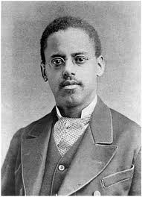
Nathaniel Alexander was the first to patent the folding chair. His invention was designed to be used in schools, churches and at large social gatherings.
http://www.biography.com/tv/classroom/black-history-inventions-and-discoveries
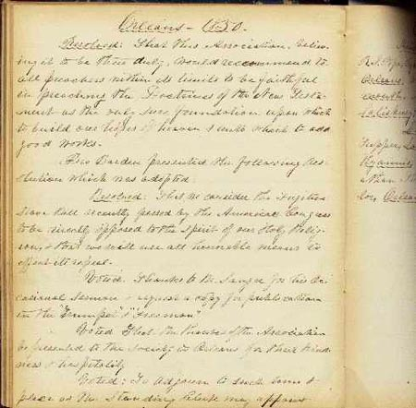
http://www.hds.harvard.edu/library/book/export/html/4351
Fugitive Slave Act of 1850
An 1850 amendment to the Fugitive Slave Act of 1793 included a provision mandating the return of fugitive slaves. About nine hundred fugitive slaves, of an estimated ten thousand, were returned under the 1850 act.

http://www.sleepingbearpress.com/teachingguides/RidingGuide.pdf
A young girl stands up against racism when she insists that a clerk allows her friend Mrs. Taylor to use the Whites Only restroom, during a bus trip to participate in the civil rights March on Washington.

